3.1

3.1.1 User ID controlled by request parameter, with unpredictable user IDs

3.1.2 **User ID controlled by request parameter with data leakage in redirect**

3.2 Insecure Direct Object References (IDOR)

## 3.3 Access control vulnerabilities in multi-step processes

## 3.4 Referer Based Access Control

## 3.5 Directory Traversal

1. Simple Case

2. File path traversal, traversal sequences blocked with absolute path bypass

3. File path traversal, traversal sequences stripped non-recursively

4. File path traversal, traversal sequences stripped with superfluous URL-decode

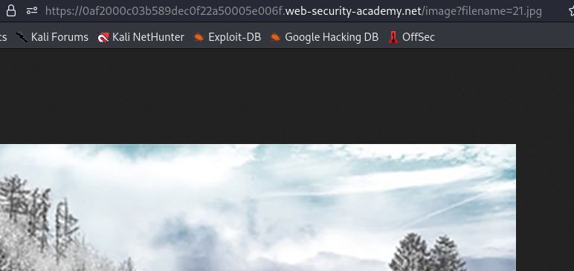

END